Application log
Assignment Date Time knots / stiches reflections
B.5 . Tying Surgical Knots  Image below  1-3 | 4/20/26 | 15mins | - Granny knot  - Square knot  - Surgeons knot | I naturally tend to make the granny knot. As a lefty I am struggling to imagine it backwards. Remembering to keeping the orientation of the knot helps to do it correctly. Also square knots remind me of interlocking belt buckles.
B.8.  Image 4-5 | 4/21/26 | 1hr  30min | - 5 simple interrupted  - 5 running/ continuous/basting,  - 5 running locked/locked blanquet (locked continuous),  - 5 Running mattress subcuticular stitch/ intradermal | It takes getting adjustments to see the driver as an extension of your hand. Once I got the hang of it. I was having fun. I started the first stitches estimating what a CM would be then pulled my ruler out and I was totally off. I then put marks to start muscle memory. The mattress stich on Gynzone was a life saver
C Oa | 4/21/26 | 1hour | - 5 simple interrupted  - 5 running/ continuous/basting,  - 5 running locked/locked blanquet (locked continuous),  - 5 Running mattress subcuticular stitch/ intradermal  - Surgeons knot | I chose not to knot this time in order to get more practice with the stitches and not waste all material. I am struggling with the subcuticular stitch in how best to hold the needle. It feels like it goes in sideways so I feel like I need to hold it differently. I don’t want to move the model so that I can pretend I am in a real scenario. Practice surgeons knot on my shoes in the car while I am passenger.
C. 0.b  Image 6-7 | 4/22/26 | 2 hours | - 5 simple interrupted  - 5 running/ continuous/basting,  - 5 running locked/locked blanquet (locked continuous),  - 5 Running mattress subcuticular stitch/ intradermal  Surgeons knot  Aberdeen knot | I started to practice on Chicken. It was another learning curve. At times the chicken just rips apart if I pull too tight so I wonder if that is a good practice too not go too tight. I am really starting to like the invisible subcuticular stitch that I learned off of gynzone.  I am a crocheter and I love that I can use those knots that I am so familiar with.
C.0.c  Image 8-9 | 4/23 | 1hour | - 5 simple interrupted  - 5 running/ continuous/basting,  - 5 running locked/locked blanquet (locked continuous),  - 5 Running mattress subcuticular stitch/ intradermal  Surgeons knot  Aberdeen knot | I have determined that interrupted stiches are my least favorite and it feels like you are getting no where. The locked blanket doesn’t bother me to do in practice but the look of them bothers me it feels off center and in my mind not correct.

1.Granny knot 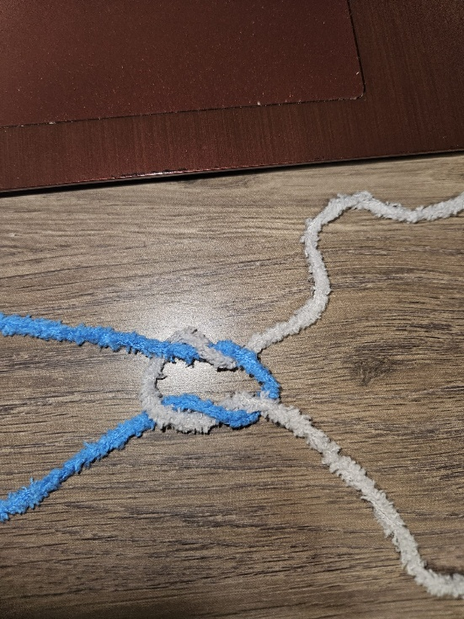
2. Square Knot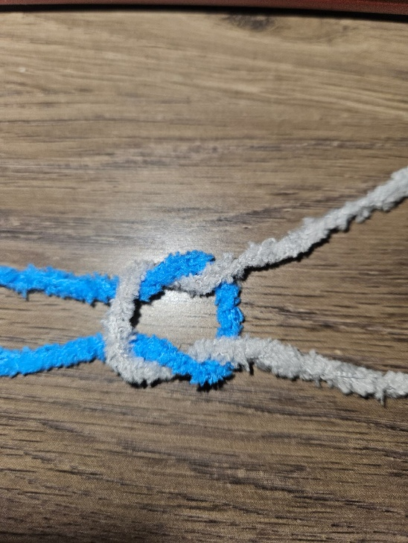
3. Sergeons knot 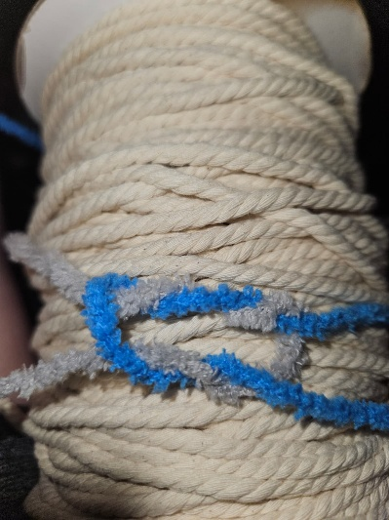

4 . before my matress stich 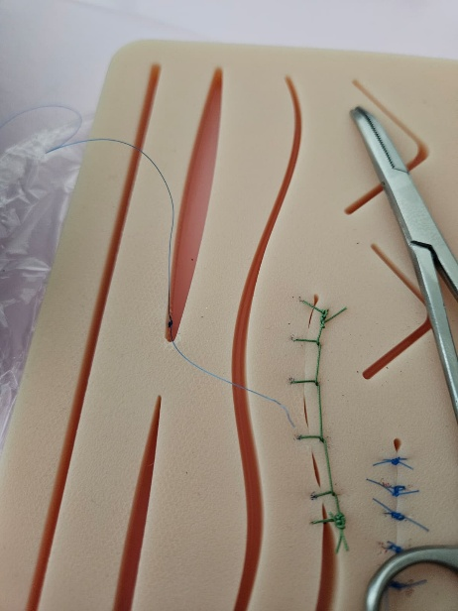
5. all of the stiches 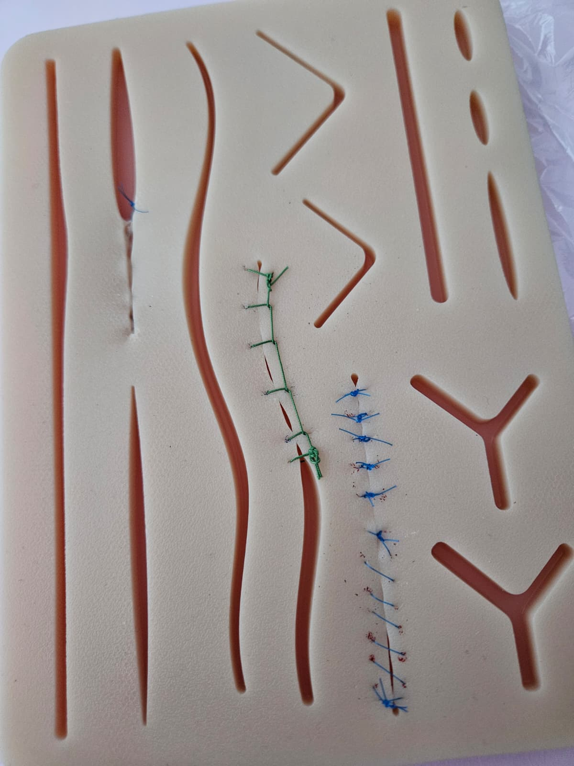

6.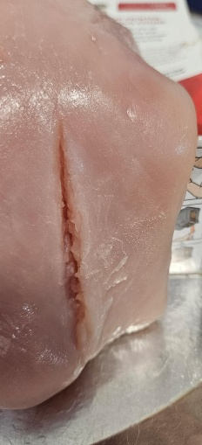
7.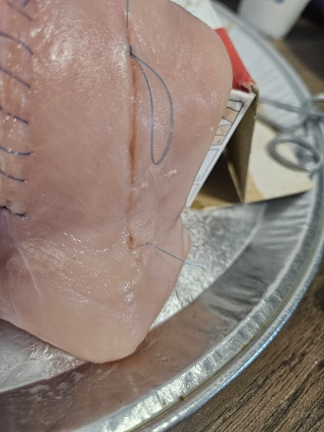
8.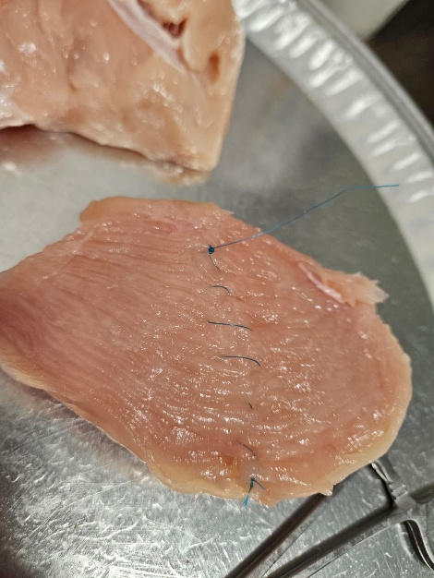I promise the last 2 stiches are the same size as the others but the ridges
Make it look otherwise.
9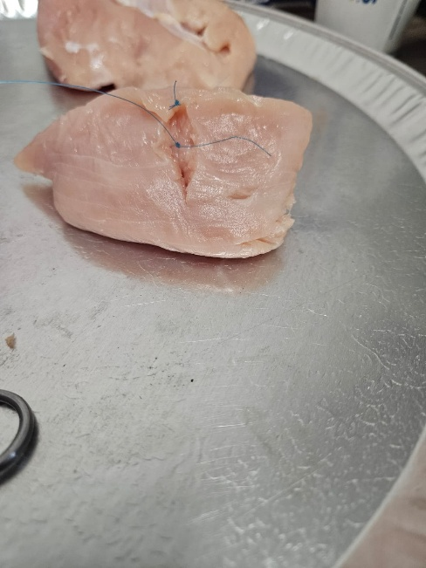

Frye, Anne, 2010. Healing Passage: A Midwife’s Guide to the Care and Repair of the Tissues
Involved in Birth, Sixth Edition. Labrys

